The Long-Term Effects of Unbalanced Parental Presence
in a Child's Developmental Years

Katrina McCardle
ECPI University
ENG 120 BO 201808E OL
Advanced Composition
Professor Provencher-Natale
September 9, 2018

The Long-Term Effects of Unbalanced Parental Presence
in a Child's Developmental Years
As demonstrated in my family as well as many I know, many children and adolescents are not raised in a whole, balanced family today. It has become increasingly common for children and adolescents to be raised by single, military, absent or separated parents with unbalanced time spent with each parent. Though it may not always be the choice of an individual or a court, the long-term effects such unbalances has on children and adolescents is tremendous. (Gorkin MSW LICSW, 2018) Therefore, this inclination has raised concern with regards to the development and future of children raised in such circumstances.
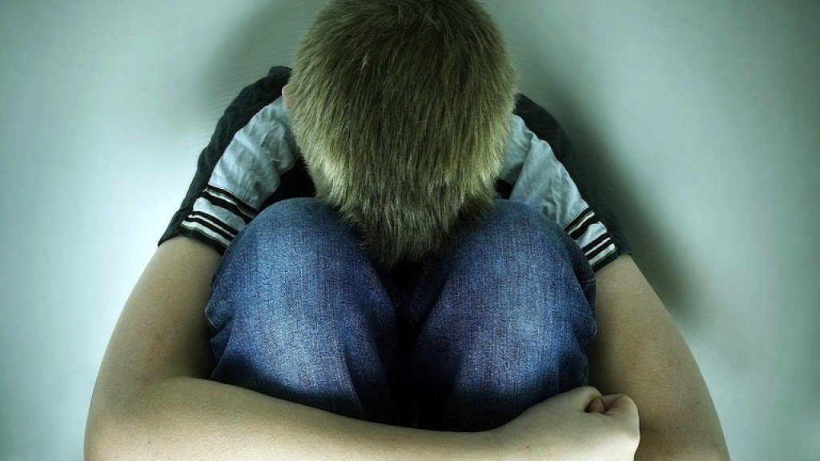
(Kismet, 2018)
Situations Leading to Unbalance
There are many reasons that would result in a child being raised in an unbalanced family unit. The most common of these is separated and/or divorced parents. In most custody cases today, family courts more often rule in favor of the mother having primary custody of a child or children regardless of the location and living situation of the father. (Gorkin MSW LICSW, 2018) This results in damaged or broken bonds between the noncustodial parent and the child or children involved. (McLanahan, Tach, & Schneider, 2014) The reason for the family courts making such unbalanced decisions is due to the antiquated belief that men are incapable of nurturing and raising children behind the means of providing for them, primarily through financial means. (Marriage and Religion Research Institute, 2018)
Another situation leading to an unbalanced familial unit is abandonment by one parent, which occurs in 93% of cases by the father rather than the mother of the child or children. (McLanahan, Tach, & Schneider, 2014) In some cases the absent parent has passed away, which leaves a tremendous void. This is especially the case if this was due to tragic circumstances, which will be discussed in greater detail later. With over three hundred twenty-five thousand United States active duty military personnel, this is a growing cause of concern for the development of military children and adolescents. (Raab, Rosenfeld, & Rosenstein, 1973) Finally, in some, rare instances, the absence of a parent is due to extenuating circumstances which resulted in the imprisonment of or termination of parental rights of one parent.

Bonds and Balance
Children develop unbreakable crucial bonds with loved ones at a young age. From birth and the following months of life, the bond between a child and their parents forms. This balance in bonding with a male and female parental figure is crucial to the development and long-term well-being of the child or children in question. An unbalanced family unit tips the scales in one direction for the child over the over, which upsets the development of that child. There are certain items that are so engrained in the nature of humans, that lack of the influence results in an unbalanced scale. (Gorkin MSW LICSW, 2018) While both love and care for their child or children, a father and a mother have very different natures, which result in a well-balanced life and development of a child or children.
By nature, the father in the provider, teaching the child or children what is necessary to succeed day-to-day and in life as such. The presence of a and bond with father figure allows a child to build confidence, self-worth, goal setting and achievement as well as pride in achievements greater than others. Conversely, the mother is, by her very nature, the caregiver and nurturer. The presence and bond with a mother figure teaches a child how to take care of and for people as well as themselves. The mother teaches a child and exercises the child’s or children’s mind beyond what they can do with their hands. As might be obvious, an unbalanced family unit results in the development of the child or children being on one side more than another. (Gorkin MSW LICSW, 2018)

Psychological Development and Disorders
Children and adolescents raised by single parents, with absent parents or in split households are more likely to have emotional, behavioral and/or mental problems in the future. Young females tend to have a stronger bond with their fathers, whereas young males tend to have a stronger bond with their mothers. Therefore, the effects of an unbalanced bond and relationship with parents can be very different for each of the genders as a basis. (Gorkin MSW LICSW, 2018) This opinion is why many people refer to someone’s relationship development issues as either a female having “daddy issues” or a male having “mommy issues.” A child develops a confidence n the opposite gender through their relationship with the parent of an opposite gender from themselves. Therefore, the lack of a healthy bond with a parent of an opposing gender is most likely to affect the child’s future and long-term ability of building healthy relationships with the opposite gender throughout their life. (Marriage and Religion Research Institute, 2018)
The lack of a balanced parental and family unit has been shown to create individual issues with self-worth and confidence. This further hinders the development of children and adolescents through adulthood, with them being far more likely to not attend college or develop a stable career. (Streep, 2013) Furthermore, more often than not, children and adolescents with unbalanced family units are more likely to develop an array of mental disorders. The most common disorders seen in children and adolescents from unbalanced family units consists of anxiety disorders, depression, eating disorders and sleep disorder. Additionally, children and adolescents from an unbalanced family unit are more likely to isolate themselves and not reach out for help when needed or deny assistance altogether. (Gorkin MSW LICSW, 2018)

Criminal Behavior
One of the most common issues arisen today with regards to the effects unbalanced parental units on the development of children and adolescents is criminal behavior. While acting out, behavioral issues and inability to cope with situations is deemed a normal, lesser occurrence when children and adolescents experience this, it is a leading factor to further issues later on. Studies have shown a child or adolescent in this situation is 62% more likely to commit a crime before the age of fifteen. Furthermore, a child or adolescent far more likely to become alcohol or chemical dependent as a coping measure with the internal deficits. (Gorkin MSW LICSW, 2018)

Social Acceptance Unbalanced Parental Relationships
As times have changed and populations have exploded, ability to share and communicate with people across the globe. This has created some things to become socially acceptable due to the sheer commonality of them and with little recourse or loss on the abandoners part. (Gorkin MSW LICSW, 2018) When my son’s biological father, whom I had been with for five years, split the country the moment I found out I was pregnant at thirteen days along, the reaction of others shocked me. Upon sharing my story with people, no one was shocked and no one offered condolences for it happens as often as changing my socks. My son’s biological father chose to never be in my son’s life and went so far as to terminate his rights, which is no fault of mine nor my son’s. I met my husband now when my son was very young and a bond was formed leading to him adopting my son, but I still worry what his life might be like if he did not have that bond.
Another socially acceptable occurrence that creates an unbalance in the family unit, is active duty military service. This is an issue I have been noticing with regards to my son and my step kids in recent years for their father has been active duty military for thirteen years. While the oldest and youngest children in our family have a well-developed and unbreakable bong with their father, the twins do not for my husband was deployed when they were merely two weeks old.
In situations where children of active duty members show symptoms relative to the active duty member’s service, a multitude of resources become available that are not available to everyone outside of the military and military dependents. The children are offered counseling, tools and knowledge to aid them in developing and understanding the situation. In addition, these children are given access to special activities and events otherwise unavailable to them as a way to cope. Outside of this setting, these resources come with a great cost many cannot afford. (Raab, Rosenfeld, & Rosenstein, 1973)

Conclusion
In conclusion, it is evident the unbalanced parental presence results in long lasting and nearly unbeatable consequences with regards to the development of children and adolescents. The only way for this matter to be overcome, is for people to become more educated in this matter. Furthermore, the making of counseling services and education materials will allow for courts to make better decisions with regards to custody and visitation situations.

References
Gorkin MSW LICSW, M. (2018). The Missing Parent Syndrome (MPS): How Psychosocial Loss Impacts Adult Children & Strategies for Building Bridges and Reworking the Grief – Pt I. MentalHelp.net. San Diego, California, United States of America. Retrieved September 1, 2018, from https://www.mentalhelp.net/blogs/the-missing-parent-syndrome-mps-how-psychosocial-loss-impacts-adult-children-amp-strategies-for-building-bridges-and-reworking-the-grief-pt-i/
Kismet, M. (2018, January 14). Psychological Effects of Growing Up Without a Father. Owlcation. Retrieved September 1, 2018, from https://owlcation.com/social-sciences/Psychological-Effects-On-Men-Growing-Up-Without-A-Father
Marriage and Religion Research Institute. (2018). Effects of Divorce on Children's Behavior. (P. F. Fagan Ph.D., Ed.) Virginia, United States of America. Retrieved September 1, 2018, from http://marripedia.org/effects.of.divorce.on.children.s.behavior
McLanahan, S., Tach, L., & Schneider, D. (2014, July 1). The Causal Effects of Father Absence. HHS Public Access. Washington D.C., United States of America: Department of Health & Human Services. doi:10.1146
Raab, M., Rosenfeld, J. M., & Rosenstein, E. (1973, January 1). Sailor Families: The Nature and Effects of One Kind of Father Absence. Child Welfare, 52(1), pp. 33-44. Retrieved September 1, 2018, from https://libproxy.ecpi.edu:2112/ehost/pdfviewer/pdfviewer?vid=7&sid=0690ff6e-8e94-4ccf-a810-cbd678b2b748%40sessionmgr4008
Streep, P. (2013, April 30). Daughters of Unloving Mothers: 7 Common Wounds: A lack of confidence and an inability to trust are just the beginning. Psychology Today. New York City, New York, United States of America: Sussex Publishers, LLC. Retrieved September 1, 2018, from https://www.psychologytoday.com/us/blog/tech-support/201304/daughters-unloving-mothers-7-common-wounds

Adolescent Behavioral Problems
By Family and Household(s) Dynamics

Figure 1 ??? (Marriage and Religion Research Institute, 2018)

What is the writer's claim (thesis statement)? What three reasons does the writer give in support of her/his claim?
Thesis statement is the unprecedented long-term effect on unbalanced parental presence. The writer indicates divorce/separation, abandonment and death of parents as reasons for unbalanced parental presence.
Evaluate the effectiveness of the writer's reasons. Does the writer provide sufficient evidence and reasoning to support the claim? Point out specific places where the evidence or reasoning should be strengthened.
The writer has demonstrated good reasons for the claim and provided sufficient evidences. However, the issue of parents’ death is concrete and needs strength to support the reason.
How effective is the organization of the paper? Do the ideas flow smoothly with strong transitions between different topics? Are there paragraphs without strong topic sentences? Be specific in pointing out any areas of weakness.
The writer is able to transit smoothly from one topic to the other; however, from the reasons to the next heading it is hard to know what the writer is talking about concerning the effects.
Does the writer use credible (believable) sources? What characteristics of the sources lead you to conclude they are credible or not? Yes, the sources are credible since they are retrieved from good websites and not blogs, and Wikipedia.
If you were to change one thing about the essay, what would it be? Please don't respond with "Nothing." Almost any piece of writing could be improved in some way. Think about places in the essay where you may have been confused or wanted more information if you are having a hard time thinking of anything.
I would change the heading leading to effects because I could not pick where the writer started to talk about the long-term effects of unbalanced parental presence.

